Lab: Arrays
Submit your solutions in the SoftUni judge system at: https://alpha.judge.softuni.org/contests/arrays-lab/1243

Sum First and Last Array Elements
Write a function that receives an array of numbers and prints the sum of the first and last element in that array.

Examples
Input | Output
[20, 30, 40] | 60
[10, 17, 22, 33] | 43
[11, 58, 69] | 80

Hints
- You can access the last element in an array by subtracting 1 from its length:
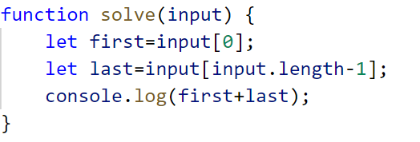

Day of Week
Write a program, which receives a number and prints the corresponding name of the day of the week (in English).
If the number is NOT a valid day, print: "Invalid day!".

Examples
Input | Output
3 | Wednesday
6 | Saturday
11 | Invalid day!

Hints
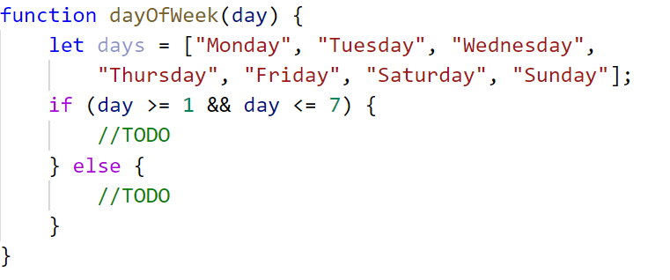

Reverse an Array of Numbers
Write a program, which receives a number n and an array of elements. Your task is to create a new array with n numbers from the original array, reverse it and print its elements on a single line, space-separated.

Examples
Input | Output
3, [10, 20, 30, 40, 50] | 30 20 10
4, [-1, 20, 99, 5] | 5 99 20 -1
2, [66, 43, 75, 89, 47] | 43 66

Hints
- Use push() to add elements inside the new array
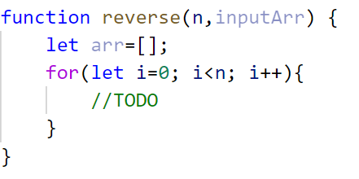
- Use string interpolation for the output
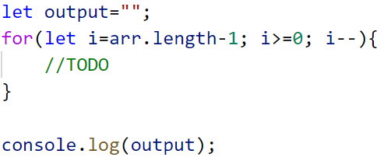

Reverse In Place
Write a program, which receives an array of strings. Your task is to reverse the array without creating a new array. Print the resulting elements on a single line, space-separated.

Examples
Input | Output | Comments
['a', 'b', 'c', 'd', 'e'] | e d c b a | The first element should be last, and the last element should be first.
['abc', 'def', 'hig', 'klm', 'nop'] | nop klm hig def abc
['33', '123', '0', 'dd'] | dd 0 123 33

Hints
- Loop to the half-length of the array
- Create a function to swap two elements inside an array
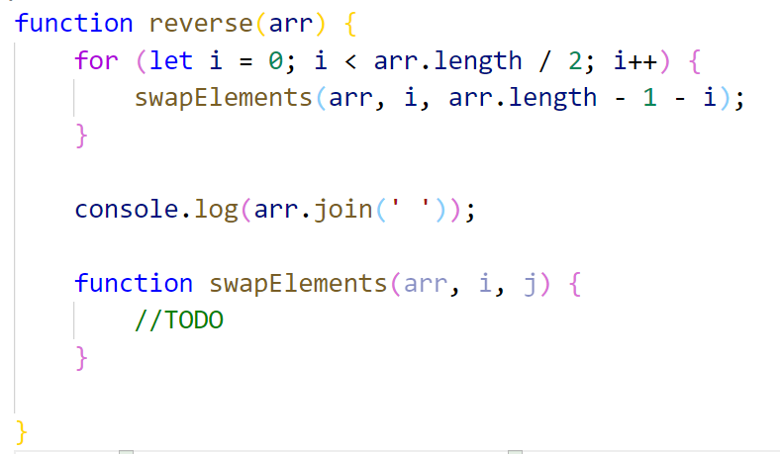

Sum Even Numbers
Write a program, which receives an array of strings, parse them into numbers, and sum only the even numbers.

Examples
Input | Output
['1','2','3','4','5','6'] | 12
['3','5','7','9'] | 0
['2','4','6','8','10'] | 30

Hints
- Parse each string to number
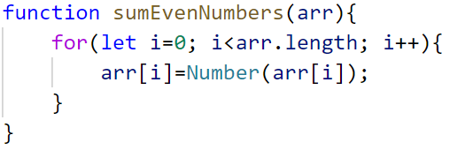
- Create a variable for the sum
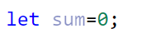
- Iterate through all elements in the array with a for-of loop
- Check if the number is even
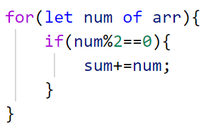
- Print the total sum

Even and Odd Subtraction
Write a program that calculates the difference between the sum of the even and the sum of the odd numbers in an array.

Examples
Input | Output | Comments
[1,2,3,4,5,6] | 3 | 2 + 4 + 6 = 12, 1 + 3 + 5 = 9, 12 - 9 = 3
[3,5,7,9] | -24
[2,4,6,8,10] | 30

Hints
- Parse each string to number
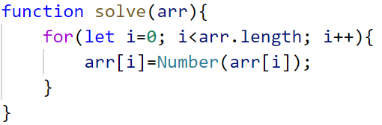
- Create two variables - for even and odd sum
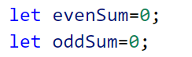
- Iterate through all elements in the array with for-of loop and check if the number is odd or even
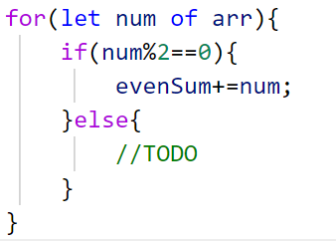
- Print the difference

Equal Arrays
Write a program, which receives two string arrays containing number representations, and prints on the console whether they are identical.
Arrays are identical if their elements at same indexes are equal. If they are identical, find the sum of the first array and print the following message:
`Arrays are identical. Sum: {sum}`
If the arrays are NOT identical, find the first index where the arrays differ and print the following message:
`Arrays are not identical. Found difference at {index} index`

Examples
Input | Output
['10','20','30'], ['10','20','30'] | Arrays are identical. Sum: 60
['1','2','3','4','5'], ['1','2','4','4','5'] | Arrays are not identical. Found difference at 2 index
['1'], ['10'] | Arrays are not identical. Found difference at 0 index

Hints
- First, we receive two arrays of strings and parse them.
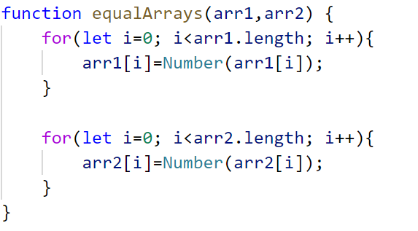
- Iterate through the arrays and compare all elements. If the elements are NOT equal, print the required message and break the loop.
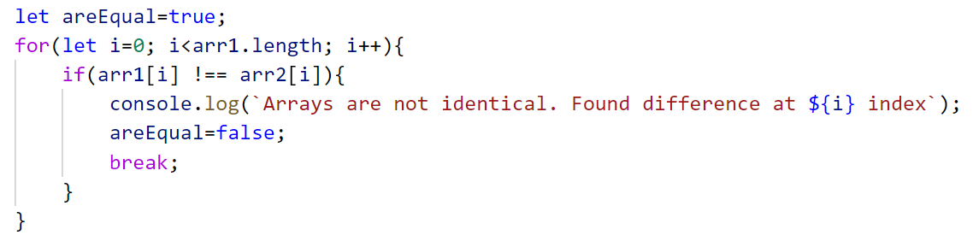
- Think about how to solve the other part of the problem.

Condense Array to Number
Write a program, which receives an array of numbers, and condenses them by summing adjacent couples of elements until a single number is obtained.

Examples
For example, if we have 3 elements [2, 10, 3], we sum the first two and the second two elements and obtain {2+10, 10+3} = {12, 13}, then we sum again all adjacent elements and obtain {12+13} = {25}.
Input | Output | Comments
[2,10,3] | 25 | 2 10 3 2+10 10+3 12 13 12 + 13 25
[5,0,4,1,2] | 35 | 5 0 4 1 2 5+0 0+4 4+1 1+2 5 4 5 3 5+4 4+5 5+3 9 9 8 9+9 9+8 18 17 18+17 35
[1] | 1 | 1 is already condensed to number

Hints
While we have more than one element in the array nums[], repeat the following:
- Allocate a new array condensed[] of size nums.Length-1.
- Sum the numbers from nums[] to condensed[]:
  - condensed[i] = nums[i] + nums[i+1]
- nums[] = condensed[]
The process is illustrated below:
